**Summary:**

Since Android activities are closely coupled to both interface and data access mechanisms our team chose the [Model - View - ViewModel design pattern](https://en.wikipedia.org/wiki/Model%E2%80%93view%E2%80%93viewmodel). The UML Class diagram shows the interaction of the ViewModel with the View and Model as well as the class relationships. The Deployment diagram and Database Entity-Relationship diagram shows the model. The UML Sequence diagram and overview Use Case diagram shows the interaction of the view with the ViewModel and Model.

**UML Class Diagram:**

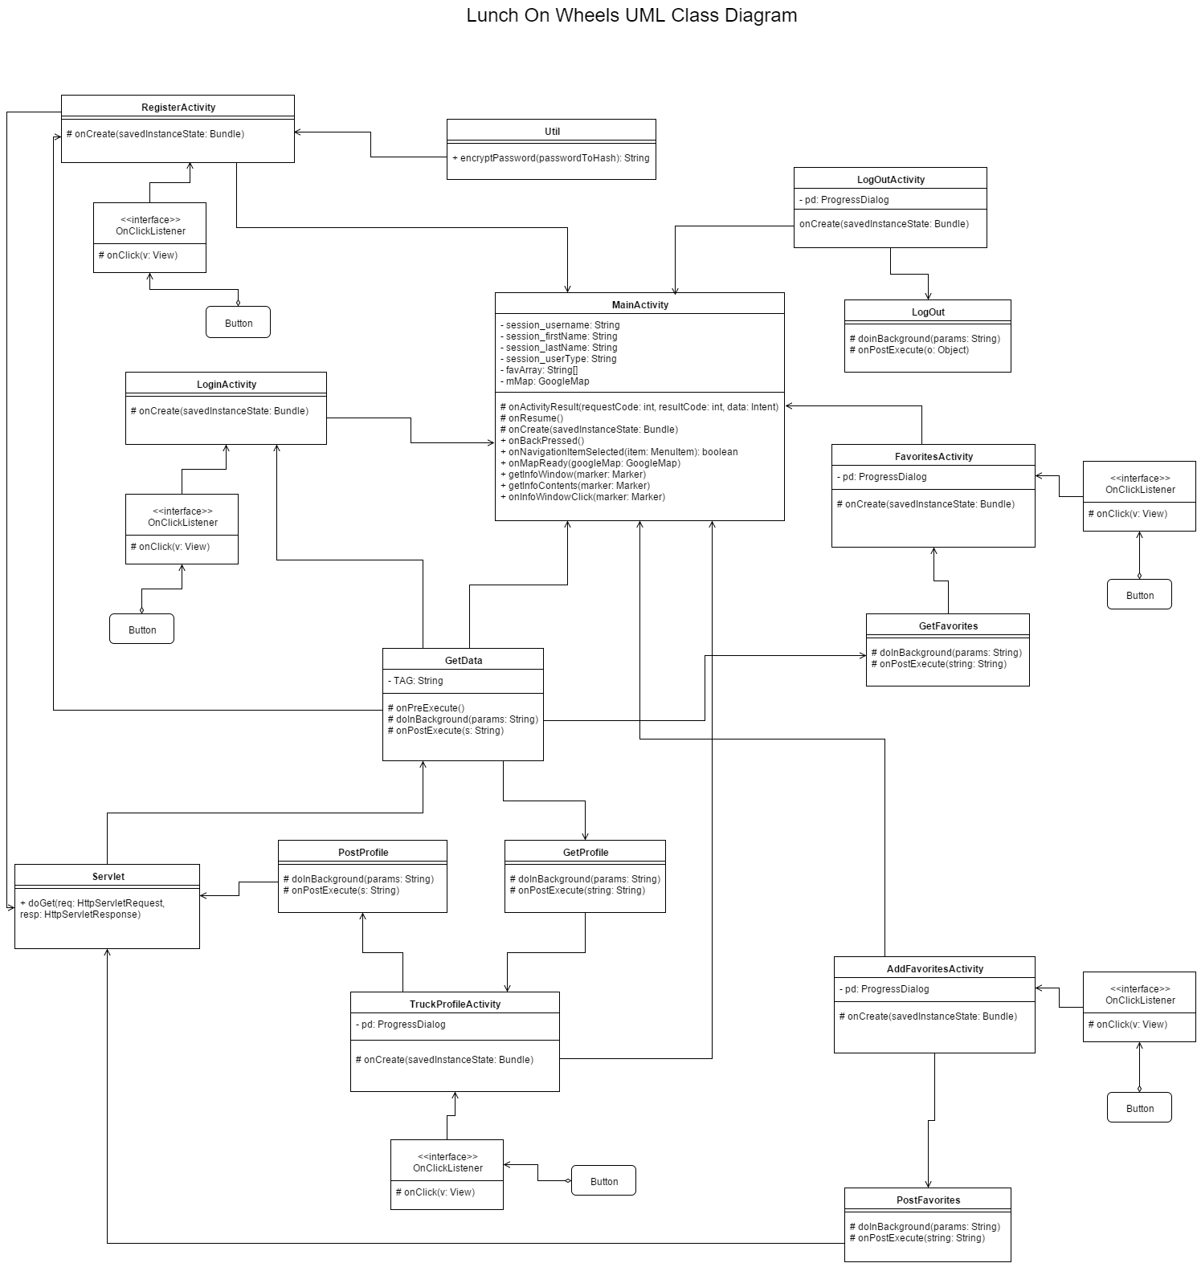

**Deployment Diagram:**

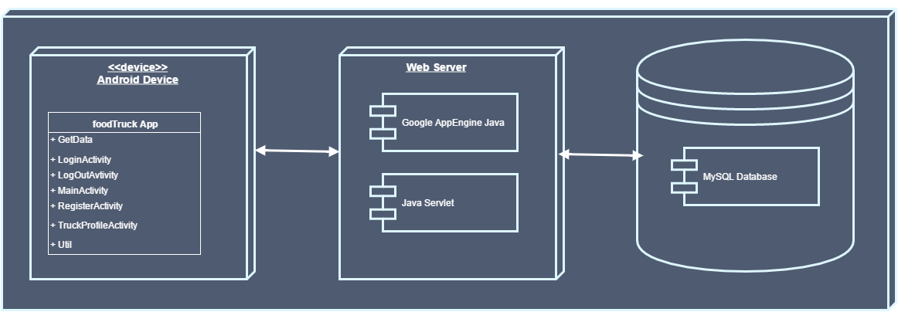

**Database Entity-Relation Diagram:**

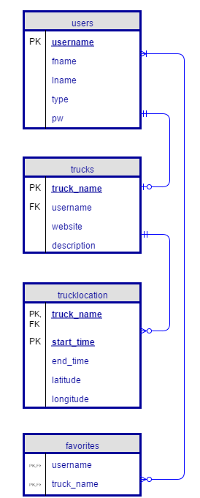

**UML Sequence Diagram:**

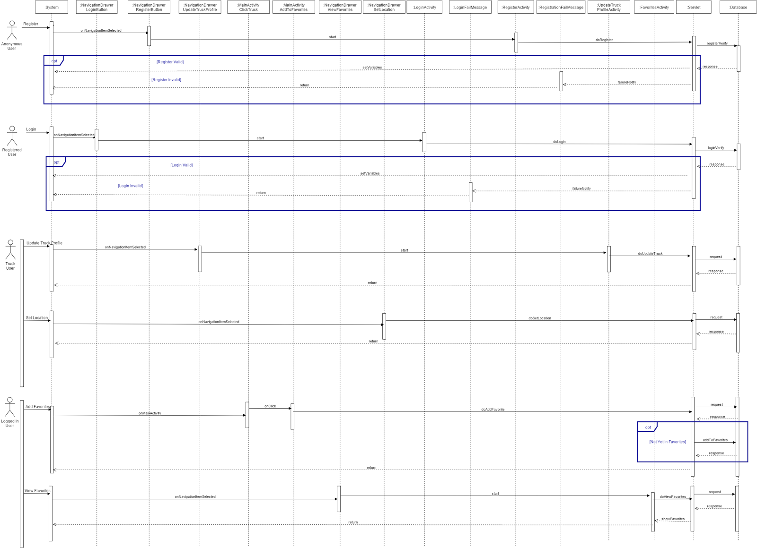

**Use Case Diagram:**

